HARD SOFT SKILLING –CHARTING YOUR CAREER PATH

**2014-1-RO01-KA201-002736_7**

**NEWSLETTER**

**08/06/2015**

**Info point-learning activity Portugal**  
The Italian students who participates in the learning activity in Portugal together with the other 6 who will join the further learning activities, organized the info point with leaflets and brochures during a day at school in order to disseminate the importance of the career plan model

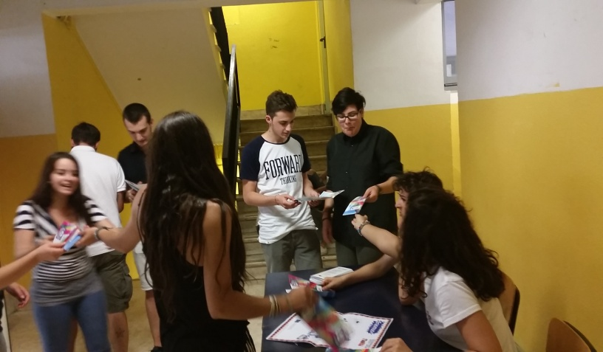

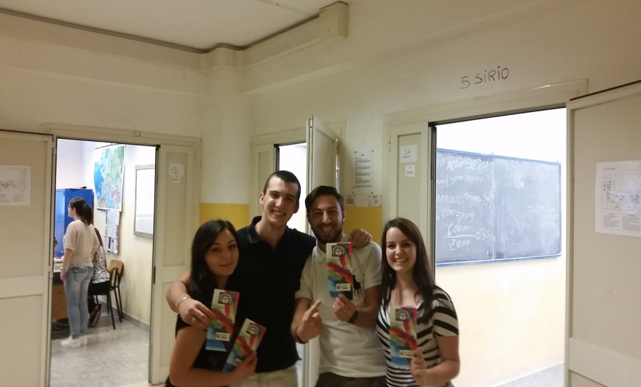

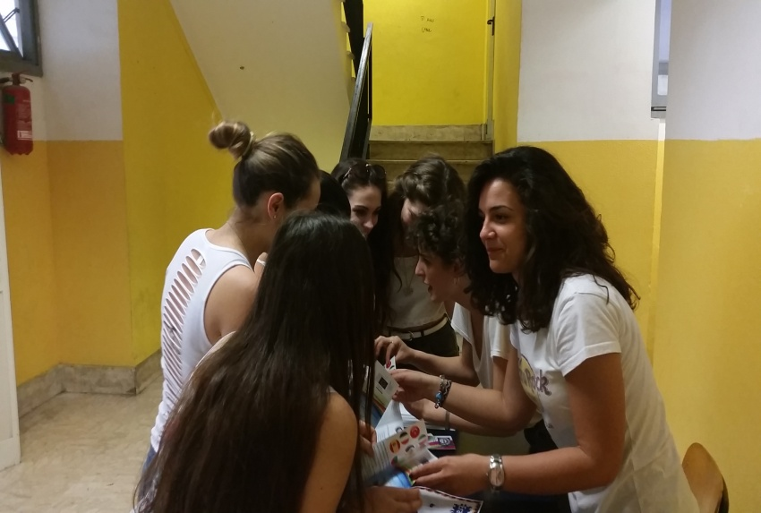

One of the class of students, who are taking part to the Erasmus plus project, during a lesson day on the activities made in Portugal

